# CS 340 README

## About the Project/Project Title

In project two, our purpose was to deliver a user-friendly, functional data analysis product to our client. We are making sure the functionality of the product meets the client specifications and giving access to read entries within the AAC database.

## Motivation

It is important to have an interface for the client so they can easily see contents within the database. In this type of database, remembering all the animals or different information about each animal can be difficult. For the client, being able to load in and have a user-friendly interface where they can sort through files is very beneficial.

## Getting Started

To get this up and running, you will need to go to your python file and save it in the same directory as your Jupyter notebook or ipynb location. You will need to understand the how to import from your python module and understand how to read the file. Once you are in Jupyter, you may run your queries to make sure you are connected to the python module, then start creating and updating. In order for the queries to run, you need to have the terminal up and logged into the user account you will be using. As mentioned earlier, you will need to have your python file located in the same directory as your ipynb file. In this project, our python file is slightly different because we used authentication. Additionally, we needed to import several features to get our program to function as we needed it to. We used different dash components to get the html portion of the code functioning, and we downloaded a png file and called it within our ipynb file.

## Installation

Within the student portal, we have the Spyder python IDE preinstalled as well as Jupyter. If you wanted to download your own python IDE, you could download one of your choice. (Eclipse, PyCharm, etc) Also, you will need to install Jupyter if you decide to use your computer locally. Once these are all functioning, you run the py module with your ipynb file.

**Challenges**

Throughout this project, I had several challenges. I started this project early on knowing that there would be a lot going on. The first issue I ran into was the authentication issue. I tried various different ways to get the authentication to pass before finally getting it to work by trying a different user. I am still unsure why one of the logins worked and one did not because the other login was working in previous modules. After I was able to get authenticated, I was able to get the program to run, but it was not producing any output. I was finally able to get it to work by going line by line and making sure all the indentations were correct. I think this may have been an issue because there were parts in the provided code that were out of place to begin with.

## Usage

### Code Example

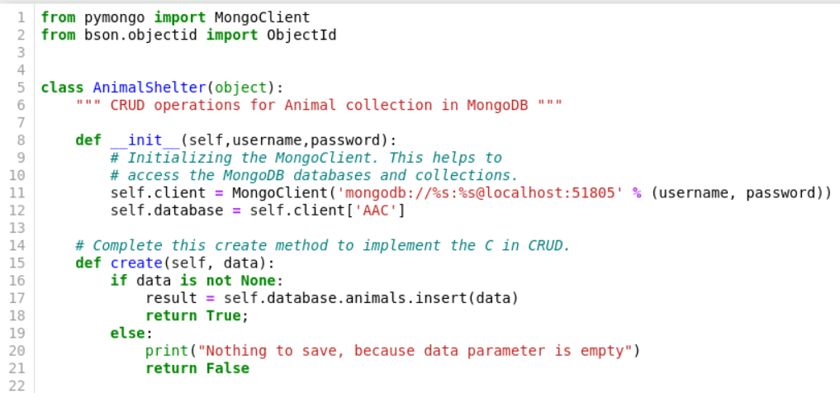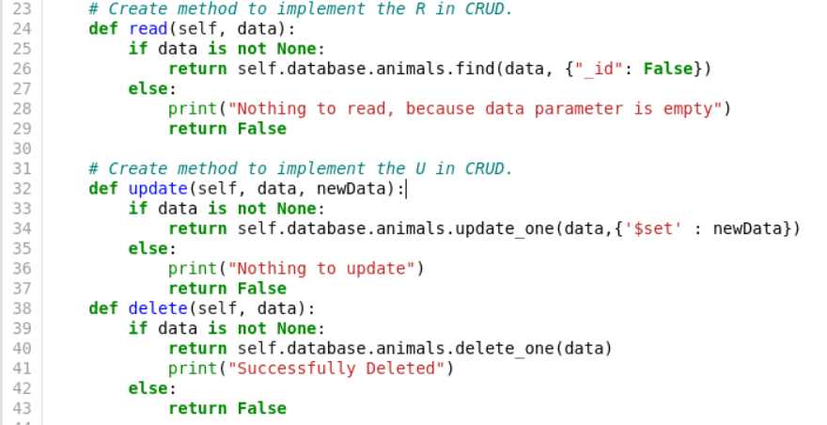

As seen in the code above, we are defining the CRUD operations in our python module. Here we make sure that all the CRUD operations are in place in the event any of them need to be used. In this project, we are mainly working with the login function and the read function.

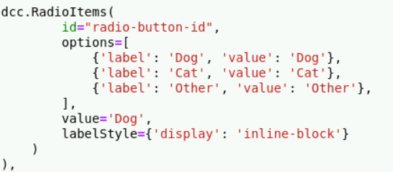

Above, we are creating the buttons we will use to sort our data and we are setting the initial value to default to Dog. When we do this, we can see when we run the program that Dog is the first button that is selected. If we wanted to default it to something else, we could adjust the code to do so.

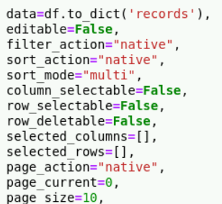

Above, we have code that we also used in previous modules. Here, we are setting up the view that the client will see. The main feature that I found helpful was setting the page limit to 10 so that it wouldn’t load everything all at once. With a large amount of data coming all at once, it could take a while to load and could make it harder to read.

**Testing:**

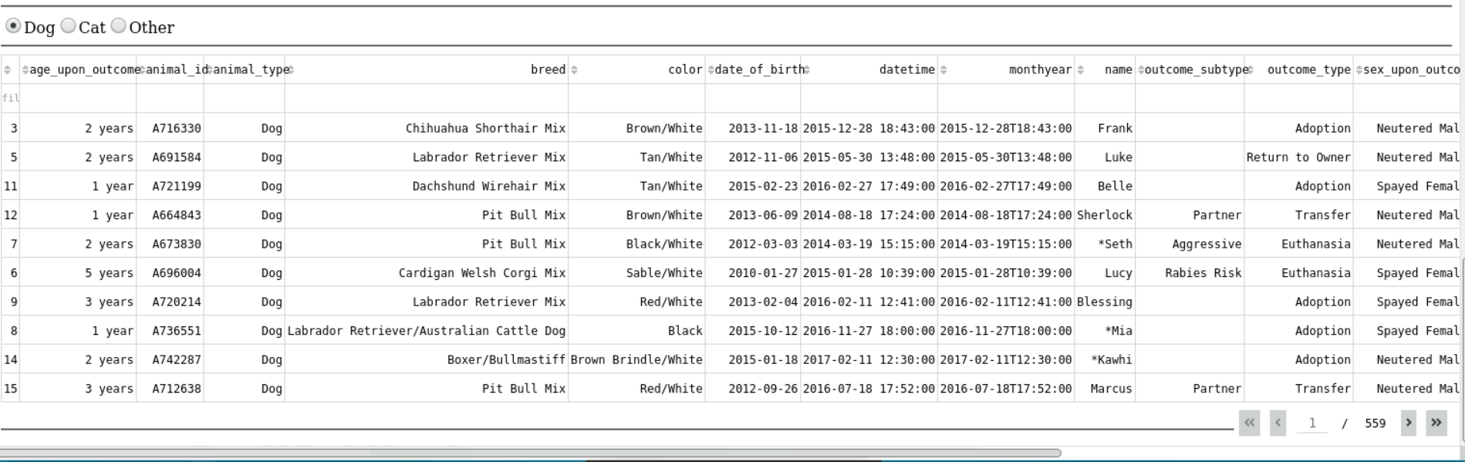

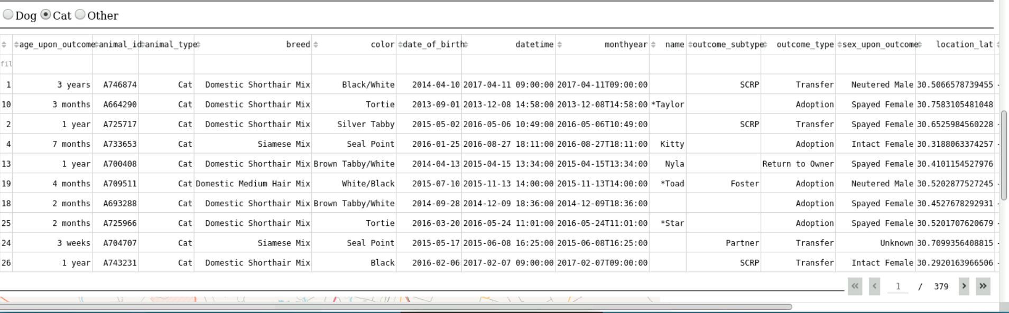

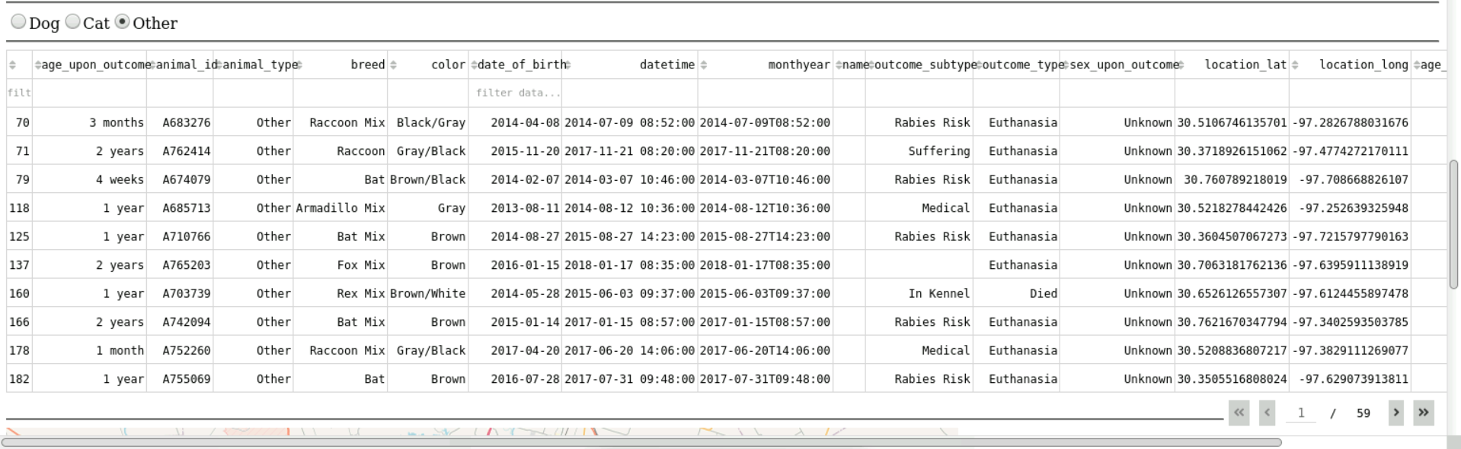

Above, we can see the code is run and I selected each radio button to sure they were functional. Screen shots are provided for each animal type: Dog, Cat, and Other. As we select each animal type, the number of pages change, and the data within each category changes as well to fit the desired output. Additionally, there are filtering options that allow the client to filter each category ascending or descending, based on the content.

## Contact

Seth Jarek

seth.jarek@snhu.edu